Laboratory vIII

Mechanical oscillations

In most of the laboratory problems this semester, objects have moved with constant acceleration because the net force acting on them has been constant. In this set of laboratory problems the force on an object, and thus its acceleration, will change with the object’s position.

You are familiar with many objects that oscillate -- a tuning fork, the balance wheel of a mechanical watch, a pendulum, or the strings of a guitar. At the atomic level, atoms oscillate within molecules, and molecules within solids. All of these objects are subjected to forces that change with position. Springs are a common example of objects that exert this type of force.

In this lab you will study oscillatory motion caused by springs exerting a force on an object. You will use different methods to determine the strength of the force exerted by different spring configurations, and investigate what quantities determine the oscillation frequency of systems.

Objectives:
After successfully completing this laboratory, you should be able to:
• provide a qualitative explanation of the behavior of oscillating systems using the concepts of restoring force and equilibrium position.
• identify the physical quantities which influence the period (or frequency) of the oscillatory motion and describe this influence quantitatively.
• demonstrate a working knowledge of the mathematical description of an oscillator's motion.
• describe qualitatively the effect of additional forces on an oscillator's motion.

Preparation:
Read Paul M. Fishbane: Chapter 13.
Before coming to lab you should be able to:
• Describe the similarities and differences in the behavior of the sine and cosine functions.
• Recognized the difference between amplitude, frequency, angular frequency, and period for repetitive motion.
• Determine the force on an object exerted by a spring using the concept of a spring constant.
Problem #1:
measuring spring constants

You are selecting springs for a large antique clock; to determine the forces they will exert in the clock, you need to know their spring constants. One book recommends a static approach: hang objects of different weights on the spring and measure the displacement from equilibrium. Another book suggests a dynamic approach: hang an object on the end of a spring and measure its oscillation frequency. You decide to compare the results of the two methods, in order to get the best precision possible for your characterization of the clock’s springs. But first you have to figure out how to calculate spring constants from each type of measurement.

Equipment

You can hang a spring from a metal rod that is fastened on a table clamp. Then you can attach an object to the hanging end of the spring. You can vary the mass of the object. A meter stick, a triple-beam balance, a stopwatch, a mass hanger, a mass set and the video analysis equipment are available for this experiment. | 

Predictions

Restate the problem. What two relationships must you calculate to prepare for your experiment?

Warm up

Read: Fishbane Chapter 13. Read carefully Section 13-3 and Example 13-4.

To figure out your predictions, it is useful to apply a problem-solving strategy such as the one outlined below:
Method #1: Suppose you hang objects of several different masses on a spring and measure the vertical displacement of each object.
1. Make two sketches of the situation, one before you attach a mass to a spring, and one after a mass is suspended from the spring and is at rest. Draw a coordinate system and label the position where the spring is unstretched, the stretched position, the mass of the object, and the spring constant. Assume the springs are massless.
2. Draw a force diagram for the object hanging at rest from the end of the spring. Label the forces. Newton's second law gives the equation of motion for the hanging object. Solve this equation for the spring constant.
3. Use your equation to sketch the displacement (from the unstretched position) versus weight graph for the object hanging at rest from the spring. How is the slope of this graph related to the spring constant?
Method #2: Suppose you hang an object from the spring, start it oscillating, and measure the period of oscillation.
1. Make a sketch of the oscillating system at a time when the object is below its equilibrium position. Draw this sketch to the side of the two sketches drawn for method #1. Identify and label this new position on the same coordinate axis.
2. Draw a force diagram of the object at this new position. Label the forces.
3. Apply Newton's second law to write down the equation of motion for the object at each of the above positions.
When the object is below its equilibrium position, how is the stretch of the spring from its unstretched position related to the position of the system's (spring & object) equilibrium position and its displacement from that equilibrium position to the position in your second sketch. Define these variables, and write an equation to show this relationship.
4. Solve your equations for acceleration of the object as a function of the mass of the suspended object, the spring constant, and the displacement of the spring/object system from its equilibrium position. Keep in mind that acceleration is second derivative of position with respect to time.
5. Try a periodic solution (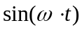or 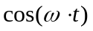) to your equation of motion (Newton's second law). Find the frequency that satisfies equation of motion for all times. How is the frequency of the system related to its period of oscillation?

Exploration

Method #1: Select a series of masses that give a usable range of displacements. The smallest mass must be much greater than the mass of the spring to fulfill the massless spring assumption. The largest mass should not pull the spring past its elastic limit (about 60 cm). Beyond that point you will damage the spring. Decide on a procedure that allows you to measure the displacement of the spring-object system in a consistent manner. Decide how many measurements you will need to make a reliable determination of the spring constant.

Method #2: Secure one end of the spring safely to the metal rod and select a mass that gives a regular oscillation without excessive wobbling to the hanging end of the spring. Again, the largest mass should not pull the spring past its elastic limit and the smallest mass should be much greater than the mass of the spring. Practice starting the mass in vertical motion smoothly and consistently.

Practice making a video to record the motion of the spring-object system. Decide how to measure the period of oscillation of the spring-object system by video and stopwatch. How can you minimize the uncertainty introduced by your reaction time in starting and stopping the stopwatch? How many times should you measure the period to get a reliable value? How will you determine the uncertainty in the period?

Measurement

Method #1: Record the masses of different hanging objects and the corresponding displacements.

Method #2: For each hanging object, record the mass of the object. Use a stopwatch to roughly determine the period of the oscillation and then make a video of the motion of the hanging object. Repeat the same procedure for objects with different masses.

Analyze your data as you go along so you can decide how many measurements you need to make to determine the spring constant accurately and reliably.

Analysis

Method #1: Make a graph of displacement versus weight for the object-spring system. From the slope of this graph, calculate the value of the spring constant, including the uncertainty.

Method #2: Determine the period of each oscillation from your videos. (Use the period by stopwatch as a predicted parameter in your fit equations.) Make a graph of period (or frequency) versus mass for the object-spring system. If this graph is not a straight line, make another graph of the period vs. some power of the mass that should produce a straight line. (Use your prediction equation to decide what that power should be.) From the slope of the straight-line graph, calculate the value of the spring constant, including the uncertainty.

Conclusion

How do the two values of the spring constant compare? Which method is faster? Which method gives you the best precision? Justify your answers in terms of your data and measurements.

Did your prediction equation for Method #2 help you correctly identify a power of the mass that would produce a straight-line graph when you were working through the analysis? Explain why or why not.

How did you minimize the uncertainty involved in the timing for Method #2? Did video analysis give you a better estimate of the period than the stopwatch?
problem #2:
the effective spring constant

Your company has bought the prototype for a new flow regulator from a local inventor. Your job is to prepare the prototype for mass production. While studying the prototype, you notice the inventor used some rather innovative spring configurations to supply the tension needed for the regulator valve. In one location the inventor had fastened two different springs side-by-side, as in Figure A below. In another location the inventor attached two different springs end-to-end, as in Figure B below.

To decrease the cost and increase the reliability of the flow regulator for mass production, you need to replace each spring configuration with a single spring. These replacement springs must exert the same forces when stretched the same amount as the original spring configurations.

The spring constant for a single spring that replaces a configuration of springs is called the configuration’s effective spring constant.

Equipment

You have two different springs with the same unstretched length, but different spring constants k1 and k2. These springs can be hung vertically side-by-side (Figure A) or end-to-end (Figure B). You will also have a meter stick, a stopwatch, a metal rod, a wooden rod, a table clamp, a mass hanger, a mass set and the video analysis equipment.
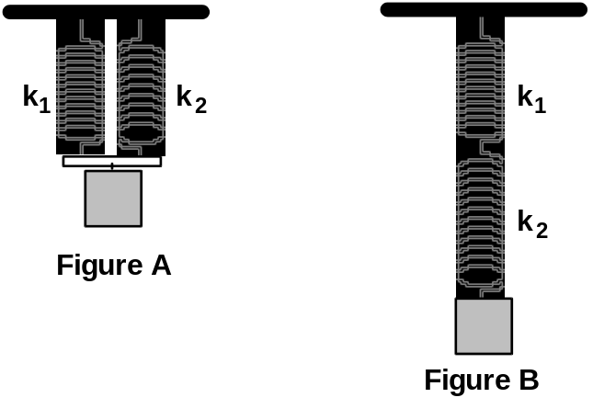

Predictions

Restate the problem. What ratios do you need to calculate for each spring configuration in the problem?

Warm up

Read: Fishbane Chapter 13. Read carefully Section 13-3 and Example 13-4.

To figure out your predictions, it is useful to apply a problem-solving strategy such as the one outlined below. Apply the strategy first to the side-by-side configuration, and then repeat for the end-to-end configuration:
1. Make a sketch of the spring configuration similar to one of the drawings in the Equipment section. Draw a coordinate system and label the positions of each unstretched spring, the final stretched position of each spring, the two spring constants, and the mass of the object suspended. Assume that the springs are massless.
For the side-by-side configuration, assume that the light bar attached to the springs remains horizontal (it does not twist).
Now make a second sketch of a single (massless) spring with spring constant k' that has the same object suspended from it and the same total stretch as the combined springs. Label this second sketch with the appropriate quantities.
2. Draw force diagrams of the object suspended from the combined springs and the same object suspended from the single replacement spring. Label the forces. Use Newton’s Third Law to identify forces on different diagrams that have the same magnitudes.
For the end-to-end configuration, draw an additional force diagram for the point at the connection of the two springs.
3. For each force diagram, write a Newton’s Second Law equation to relate the net force on an object (or the point connecting the springs) to its acceleration.
Write an equation relating the total stretch of the combined springs related to the stretch of each of the springs? How does this compare to the stretch of the single replacement spring? How does the stretch of each spring relate to its spring constant and the force it exerts?
4. Re-write each Newton’s second law equation in terms of the stretch of each spring.
For the end-to-end configuration: At the connection point of the two springs, what is the force of the top spring on the bottom spring? What is the force of the bottom spring on the top spring?
5. Solve your equations for the effective spring constant (k') of the single replacement spring, in terms of the two spring constants.

Exploration

To test your predictions, you must decide how to measure each spring constant of the two springs and the effective spring constants of the side-by-side and end-to-end configurations.

From your results of Problem #1, select the best method for measuring spring constants. Justify your choice. DO NOT STRETCH THE SPRINGS PAST THEIR ELASTIC LIMIT (ABOUT 60 CM) OR YOU WILL DAMAGE THEM.

Perform an exploration consistent with your selected method. If necessary, refer back to the appropriate Exploration section of Problem #1.

Remember, the smallest mass must be much greater than the mass of the spring to fulfill the massless spring assumption. The largest mass should not pull the spring past its elastic limit.

Outline your measurement plan.

Measurement

Make the measurements that are consistent with your selected method. If necessary, refer back to the appropriate Measurement section of Problem #1. What are the uncertainties in your measurements?

Analysis

Determine the effective spring constants (with uncertainties) of the side-by-side spring configuration and the end-to-end spring configuration. If necessary, refer back to Problem #1 for the analysis technique consistent with your selected method.

Determine the spring constants of the two springs. Calculate the effective spring constants (with uncertainties) of the two configurations using your Prediction equations.

How do the measured and predicted values of the effective spring constants for the two configurations compare?

Conclusion

What are the effective spring constants of a side-by-side spring configuration and an end-to-end spring configuration? Did your measured values agree with your initial predictions? Why or why not? What are the limitations on the accuracy of your measurements and analysis?

Which configuration provides a larger effective spring constant?
problem #3:
oscillation frequency with two springs

You have a summer job with a research group at the University. Your supervisor asks you to design equipment to measure earthquake aftershocks. The calibration sensor needs to be isolated from the earth movements, yet free to move. You decide to place the sensor on a track cart and attach a spring to both sides of the cart. You should now be able to measure the component of the aftershocks along the axis defined by the track. To make any quantitative measurements with the sensor you need to know the frequency of oscillation for the cart as a function of the spring constants and the mass of the cart.

Equipment

You will have an aluminum track, two adjustable end stops, two oscillation springs, a meter stick, a stopwatch, a cart and the video analysis equipment.

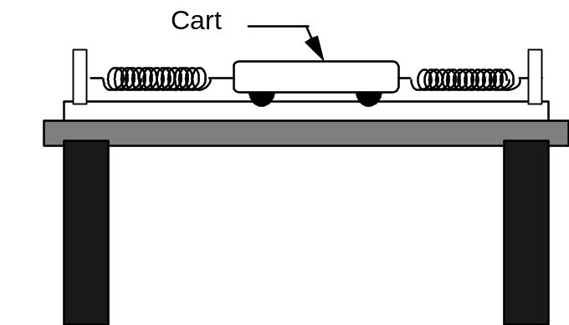

Prediction

Restate the problem. What quantities do you need to calculate to test your design?

Warm up

Read: Fishbane Chapter 13. Read carefully Sections 13-3 and 13-4 and Examples 13-6.
To figure out your prediction, it is useful to use a problem-solving strategy such as the one outlined below:
1. Make two sketches of the oscillating cart, one at its equilibrium position, and one at some other position and time while it is oscillating. On your sketches, show the direction of the velocity and acceleration of the cart. Identify and label the known (measurable) and unknown quantities.
2. Draw a force diagram of the oscillating cart away from its equilibrium position. Label the forces.
3. Apply Newton's laws as the equation of motion for the cart. Consider both cases when the cart is in the equilibrium and displaced from the equilibrium position.
Solve your equation for the acceleration, simplifying the equation until it is similar to equation 13-14 (Fishbane).
4. Try a periodic solution (or ) to your equation of motion (Newton's second law). Find the frequency that satisfies equation of motion for all times. How is the frequency of the system related to its period of oscillation? Calculate frequency of the system as a function of the mass of the cart and the two spring constants.
5. Use the simulation “LabSim5” (See Appendix F for a brief explanation of how to use the simulations) to approximate the conditions of this problem.

Exploration

Decide the best method to determine the spring constants based on your results of Problem #1. DO NOT STRETCH THE SPRINGS PAST THEIR ELASTIC LIMIT (ABOUT 60 CM) OR YOU WILL DAMAGE THEM.

Find the best place for the adjustable end stop on the track. Do not stretch the springs past 60 cm, but stretch them enough so they oscillate the cart smoothly.

Practice releasing the cart smoothly. You may notice the amplitude of oscillation decreases. What’s the reason for it? Does this affect the period of oscillation?

Measurement

Determine the spring constants. Record these values. What is the uncertainty in these measurements?

Record the mass of the cart. Use a stopwatch to roughly determine the period of oscillation and then make a video of the motion of the oscillating cart. You should record at least 3 cycles.

Analysis

Analyze your video to find the period of oscillation. Calculate the frequency (with uncertainty) of the oscillations from your measured period.

Calculate the frequency (with uncertainty) using your Prediction equation.

Conclusion

What is the frequency of the oscillating cart? Did your measured frequency agree with your predicted frequency? Why or why not? What are the limitations on the accuracy of your measurements and analysis? What is the effect of friction?

If you completed Problem #2: What is the effective spring constant of this configuration? How does it compare with the effective spring constants of the side-by-side and end-to-end configurations?
problem #4:
oscillation frequency of an extended system

You are the technical advisor for the next Bruce Willis action movie, Die Even Harder, which is to be filmed in Minnesota. The script calls for a spectacular stunt. Bruce Willis dangles over a cliff from a long rope whose other end is tied to the Bad Guy. The Bad Guy is on the ice-covered ledge of the cliff. The Bad Guy's elastic parachute line is tangled in a tree located several feet from the edge of the cliff. Bruce and the Bad Guy are in simple harmonic motion, and at the top of his motion, Bruce unsuccessfully tries to grab for the safety of the cliff edge while the Bad Guy reaches for his discarded knife. The script calls for Bad Guy to cut the rope just as Bruce reaches the top of his motion again.

The problem is that it is expensive to have Bruce hanging from the rope while the crew films close-ups of the Bad Guy, but the stunt double weighs at least 50 pounds more than Bruce. The director wants to know if the stunt double will have a different motion than Bruce, and if so whether the difference would be noticeable. Will he?

You decide to test your prediction by modeling the situation with the equipment described below.

Equipment

You have an aluminum track with an adjustable end stop, a pulley, a pulley clamp, an oscillation spring, a cart, some strings, a mass hanger, a mass set, a meter stick, a stopwatch and the video analysis equipment.

The track represents the ice-covered ledge of the cliff, the adjustable end-stop represents the tree, the spring represents the elastic cord, the cart represents the Bad Guy, the string represents the rope and the hanging object represents Bruce Willis or his stunt double in this problem.

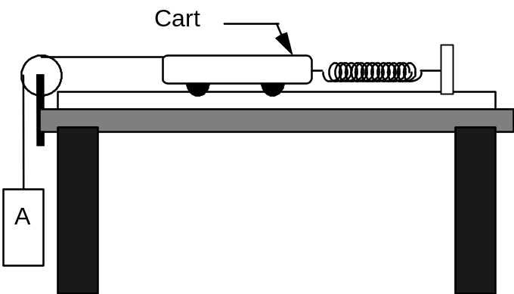

Prediction

Restate the problem. What quantities must you calculate to answer the director’s question?

Warm up

Read: Fishbane Chapter 13. Read carefully Section 13-4 and Examples 13-5 and 13-6.
To figure out your prediction, it is useful to use a problem-solving strategy such as the one outlined below:
1. Make sketches of the situation when the cart and hanging object are at their equilibrium positions and at some other time while the system is oscillating. On your sketches, show the direction of the acceleration of the cart and hanging object. Identify and label the known (measurable) and unknown quantities.
2. Draw separate force diagrams of the oscillating cart and hanging object. Label each force. Are there any third-law pairs?
3. Independently apply Newton's laws to the cart and to the hanging object.
4. Solve your equations for the acceleration, simplifying the equation until it is similar to equation 13-14 (Fishbane).
5. Try a periodic solution [or ] to your equation of motion (Newton's second law). Find the frequency that satisfies equation of motion for all times. How is the frequency of the system related to its period of oscillation? Calculate frequency of the system as a function of the mass of the cart, the mass of the hanging object, and the spring constant.
6. Use your equation to sketch the expected shape of a graph of the oscillation frequency versus hanging mass. Will the frequency increase, decrease or stay the same as the hanging mass increases?
7. Now you can complete your prediction. Use your equation to sketch the expected shape of the graph of oscillation frequency versus the hanging object's mass.

Exploration

If you do not know the spring constant of your spring, you should decide the best way to determine the spring constant based on your results of Problem #1.

Find the best place for the adjustable end stop on the track. DO NOT STRETCH THE SPRING PAST 60 CM OR YOU WILL DAMAGE IT, but stretch it enough so the cart and hanging mass oscillate smoothly. Determine the best range of hanging masses to use.

Practice releasing the cart and hanging mass smoothly and consistently. You may notice the amplitude of oscillation decreases. What’s the reason for it? Does this affect the period of oscillation?

Measurement

If necessary, determine the spring constant of your spring. What is the uncertainty in your measurement?

For each hanging object, record the masses of the cart and the hanging object. Use a stopwatch to roughly determine the period of oscillation and then make a video of the oscillating cart for each hanging object. You should record at least 3 cycles for each video.
Analyze your data as you go along, so you can determine the size and number of different hanging masses you need to use.

Collect enough data to convince yourself and others of your conclusion about how the oscillation frequency depends on the hanging mass.

Analysis

For each hanging object, digitize the video to get the period of oscillation and then calculate the oscillation frequency (with uncertainty) from your measured period.

Graph the frequency versus the hanging object's mass. On the same graph, show your predicted relationship.

What are the limitations on the accuracy of your measurements and analysis? Over what range of values does the measured graph match the predicted graph best? Do the two curves start to diverge from one another? If so, where? What does this tell you about the system?

Conclusion

Does the oscillation frequency increase, decrease or stay the same as the hanging object's mass increases? State your result in the most general terms supported by your analysis.

What will you tell the director? Do you think the motion of the actors in the stunt will change if the heavier stunt man is used instead of Bruce Willis? How much heavier than Bruce would the stunt man have to be to produce a noticeable difference in the oscillation frequency of the actors? Explain your reasoning in terms the director would understand so you can collect your paycheck.
problem #5:
driven oscillations

You are now prepared to calibrate your seismic detector (from Problem #3). You need to determine how the amplitude of the oscillations of the detector will vary with the frequency of the earthquake aftershocks. So you replace the end stop on the track with a device that moves the end of the spring back and forth, simulating the earth moving beneath the track. The device, called a mechanical oscillator, is designed so you can change its frequency of oscillation.

Equipment

You will use your seismic detector apparatus and a mechanical oscillator.

The mechanical oscillator is somewhat like a loudspeaker with one end of a metal rod attached to the center, and the other end of the rod is attached to one of the springs. The oscillator is connected to a function generator which causes the rod to oscillate back and forth with adjustable frequencies which can be read from the display on the function generator.
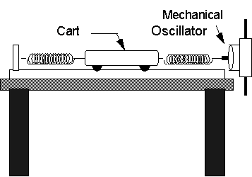

You will also have a meter stick, a stopwatch, a metal rod, a table clamp, an end stop, two oscillation springs and two banana cables.

Prediction

Make your best-guess sketch of what you think a graph of the amplitude of the cart versus the frequency of the mechanical driver will look like. Assume the mechanical oscillator has constant amplitude of a few millimeters.

Warm up

Read: Fishbane Chapter 13. Read carefully Section 13-8. Use the simulation “LabSim5” (See Appendix F for a brief explanation of how to use the simulations) to approximate the conditions of this problem.

Exploration

Examine the mechanical oscillator. Mount it at the end of the aluminum track, using the clamp and metal rod so its shaft is aligned with the cart's motion. Connect it to the function generator, using the output marked Lo (for ``low impedance''). Use middle or maximum amplitude to observe the oscillation of the cart at the lowest frequency possible.

Determine the accuracy of the digital display on the frequency generator by timing one of the lower frequencies. Devise a scheme to accurately determine the amplitude of a cart on the track, and practice the technique. For each new frequency, should you restart the cart at rest?

When the mechanical oscillator is at or near the un-driven frequency (natural frequency) of the cart-spring system, try to simultaneously observe the motion of the cart and the shaft of the mechanical oscillator. What is the relationship? What happens when the oscillator’s frequency is twice as large as the natural frequency?

Measurement

If you do not know the natural frequency of your system when it is not driven, determine it using the technique of Problem #3. Collect enough cart amplitude and oscillator frequency data to test your prediction. Be sure to collect several data points near the natural frequency of the system.

Analysis

Make a graph the oscillation amplitude of the cart versus oscillator frequency. Is this the graph you had anticipated? Where is it different? Why? What is the limitation on the accuracy of your measurements and analysis?

Conclusion

Can you explain your results? Is energy conserved? What will you tell your boss about your design for a seismic detector?

1. The diagram below shows an oscillating mass/spring system at times 0, T/4, T/2, 3T/4, and T, where T is the period of oscillation. For each of these times, write an expression for the displacement (x), the velocity (v), the acceleration (a), the kinetic energy (KE), and the potential energy (PE) in terms of the amplitude of the oscillations (A), the angular velocity (w), and the spring constant (k).

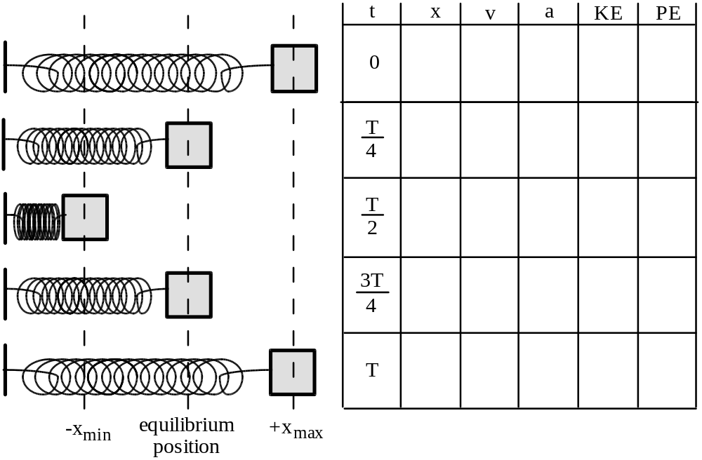

2. Identical masses are attached to identical springs which hang vertically. The masses are pulled down and released, but mass B is pulled further down than mass A, as shown at right.  a. Which mass will take a longer time to reach the equilibrium position? Explain.  b. Which mass will have the greater acceleration at the instant of release, or will they have the same acceleration? Explain.  c. Which mass will be going faster as it passes through equilibrium, or will they | 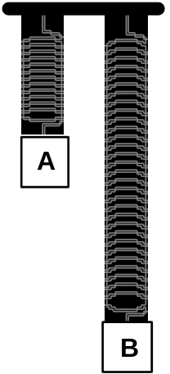
have the same speed? Explain.

d. Which mass will have the greater acceleration at the equilibrium point, or will they have the same acceleration? Explain.

3. Two different masses are attached to different springs which hang vertically. Mass A is larger, but the period of simple harmonic motion is the same for both systems. They are pulled the same distance below their equilibrium positions and released from rest. | 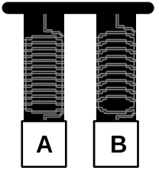

a. Which spring has the greater spring constant? Explain.

b. Which spring is stretched more at its equilibrium position? Explain.

c. The instant after release, which mass has the greater acceleration? Explain.

d. If potential energy is defined to be zero at the equilibrium position for each mass, which system has the greater total energy of motion? Explain.

e. Which mass will have the greater kinetic energy as it passes through its equilibrium position? Explain

f. Which mass will have the greater speed as it passes through equilibrium? Explain.

4. Five identical springs and three identical masses are arranged as shown at right.  a. Compare the stretches of the springs at equilibrium in the three cases. Explain.  b. Which case, a, b, or c, has the greatest effective spring constant? The smallest effective spring constant? | 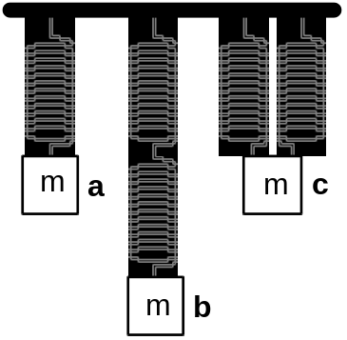
Explain.

c. Which case would execute simple harmonic motion with the greatest period? With the least period? Explain.

PHYSICS 1301 LABORATORY REPORT

Laboratory VIII

Name and ID#:
Date performed: Day/Time section meets:
Lab Partners' Names:
Problem # and Title:
Lab Instructor's Initials:
Grading Checklist | Points*
LABORATORY JOURNAL:
PREDICTIONS
(individual predictions and warm-up completed in journal before each lab session)
LAB PROCEDURE
(measurement plan recorded in journal, tables and graphs made in journal as data is collected, observations written in journal)
PROBLEM REPORT:
ORGANIZATION
(clear and readable; logical progression from problem statement through conclusions; pictures provided where necessary; correct grammar and spelling; section headings provided; physics stated correctly)
DATA AND DATA TABLES
(clear and readable; units and assigned uncertainties clearly stated)
RESULTS
(results clearly indicated; correct, logical, and well-organized calculations with uncertainties indicated; scales, labels and uncertainties on graphs; physics stated correctly)
CONCLUSIONS
(comparison to prediction & theory discussed with physics stated correctly ; possible sources of uncertainties identified; attention called to experimental problems)
TOTAL(incorrect or missing statement of physics will result in a maximum of 60% of the total points achieved; incorrect grammar or spelling will result in a maximum of 70% of the total points achieved)
BONUS POINTS FOR TEAMWORK
(as specified by course policy)

* An "R" in the points column means to rewrite that section only and return it to your lab instructor within two days of the return of the report to you.

